Appreciate What Your Body Can Do

So often we are caught up in how we look that we forget to think about all of the things our bodies can do. I don't just mean lifting heavy weights or performing well at the gym, although that's great too. Our bodies perform so many functions for us.

Appreciating, respecting and honouring your body for what it is capable of doing can help you to feel more satisfied with your body and move away from worrying too much about your appearance.

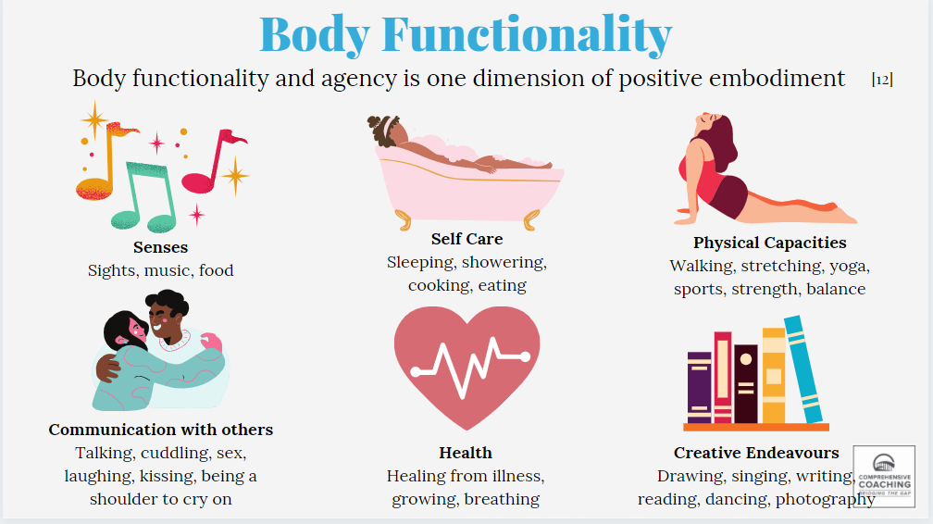

List all of the things that you appreciate about your body:

Senses:
Self-Care:
Physical Capacities:
Communication With Others:
Health:
Creative Endeavours:

Now think, how dull would life be if you couldn’t taste food or listen to music? Where would you be if you couldn’t communicate with others using your body (to give hugs, hold hands)? What if your body couldn’t take care of itself and protect you against illnesses?

