Monitor Your Body-Checking Behaviours

Body checking: a behavioural component of body image that occurs when one repeatedly checks their weight and shape. Common body checking behaviours include self-weighing, staring in the mirror, comparing oneself to other people, or pinching various body parts to assess for fat and muscle.

Most of us don't realise how often we check our bodies. How many times a day do you look in the mirror? Or pinch your body fat?

These behaviours can become so habitual that we often do them unconsciously.

There's nothing wrong with looking at yourself every now and then but there's a big difference between simply fixing your appearance and constantly feeling compelled to inspect, scrutinise and pick at your body.

It can also be problematic when you are relying on your body to make you feel good, i.e. being pleased that you look lean and constantly checking to see if that is still the case.

This just serves to reinforce the idea that it's important to tightly control how we look. Usually, this just makes us feel crap and feeds into a negative cycle that's hard to break.

It's really worth monitoring and addressing these behaviours. It's hard to improve your body image if you're always thinking about how you look.

It's not our bodies that need to change. It's the way we think about them.

Monitor how frequently you check your body using the example on the next page.
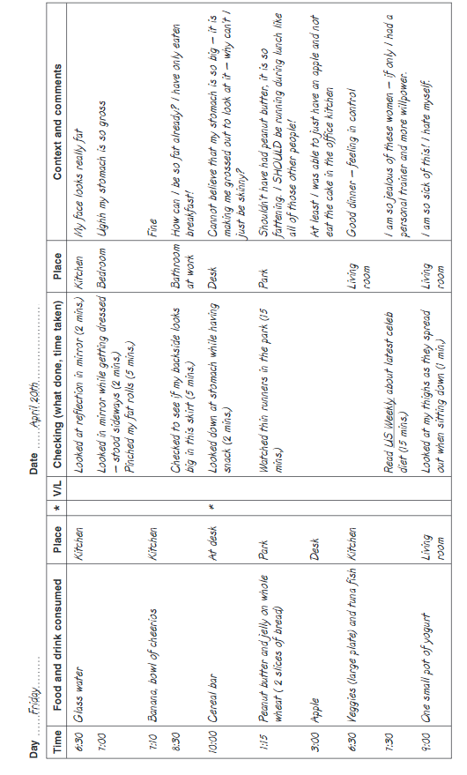

Time | Place | Checking (what done, time taken) | Context and comments
7am | Bedroom | Checked my stomach in the mirror for a few minutes, pinching the bits I don’t like (5 mins) | Just woken up and feeling bloated. Not happy with how much fat I can pinch. I will have to eat a bit less today. I feel so gross.

Ask yourself the following questions:

What are you trying to find out when you check your body? Do you think you can find it out this way?

Most forms of body checking do not generate sufficiently reliable quantitative information to detect change. Instead they simply provide an impression about shape. Checking oneself in the mirror is a good example. We cannot with any accuracy compare one “look” say first thing in the morning with another “look” a few hours later because we do not have a photographic memory of the type that would enable us to contrast the first image with the second.

Why are you checking yourself so frequently? Do you think you might be checking yourself too often?

Do you think your shape is really changing so frequently to justify how often you check yourself?

Do you feel better after checking your body?

